SOUTHWESTERN UNIVERSITY
Workers' Compensation
Program Guide

Workers’ Compensation is a state-regulated insurance program that pays medical bills and replaces some lost wages for employees who are injured at work or who have work related diseases or illnesses.

I. What Is Workers' Compensation Insurance?

Workers' Compensation Insurance is a type of insurance specifically designed to provide medical benefits and, in some cases, income benefits to employees on the payroll of Southwestern University who suffer injuries or occupational diseases in the course and scope of employment. In some cases, death and burial benefits may be applicable.

In instances of injury or illness arising out of or in the course of employment, the employee is entitled to medical benefits including all medical aid, hospital services, and medication reasonably required at the time of injury and anytime thereafter to cure and relieve the effects naturally resulting from the injury.

There are four types of income benefits to which an injured employee may be eligible: 1) temporary income benefits; 2) impairment income benefits; 3) supplemental income benefits and, 4) lifetime income benefits.

Workers' Compensation Insurance is not health insurance, nor does it provide compensation for damage to or loss of personal property.

For more information regarding Department of Workers’ Compensation (DWC), refer to www.tdi.texas.gov/wc/ .

II. Who will be handling the Workers' Compensation claim?

If you decide to file a claim for a work-related injury/illness, your claim file will be managed by Human Resources in conjunction with Travelers Indemnity Company, the workers' compensation carrier for the University. For all work-related injuries requiring medical attention, Travelers will assign a claims adjuster. Any bills for your work related injury should be sent directly to:

Travelers
Workers' Compensation Claims
P.O. Box 42927
Houston, TX 77242-2927
(800) 235-3610

For pharmacy prescription authorization contact HealtheSystems at (800) 964-1681.

III. What does an employee need to do if injured while on the job?

If you are injured while performing work on behalf of the University or if you acquire an occupational disease as a direct result of your employment, you should immediately inform your supervisor of the injury or disease and then proceed to Human Resources. If you require medical treatment for a work-related injury, Human Resources will help coordinate your care with a doctor who is approved to treat Texas workers’ compensation injuries. Please note that it is the employee’s responsibility to file a workers’ compensation claim and filing the claim is at the employee’s discretion.

In the case of an emergency your injury should be immediately reported to your department so that the appropriate personnel can be dispatched to transport you to the nearest emergency facility. Once back from the emergency facility, the Accident Report Form must be completed.

In non-emergency situations, the employee and their supervisor will complete the Accident Report Form which is then sent, via email attachment, to the Human Resources representative for Workers Compensation (laduquet@southwestern) and the Safety Officer (delancem@southwestern). Print out a hard copy of the form in order for the employee and their supervisor to sign. Then proceed to the Human Resources department with the hard copy.

Once at Human Resources, the Workers’ Compensation Coordinator will go over the Accident Report with the employee and discuss if medical attention is needed. Transportation, if needed, will be provided for all injured workers requiring medical attention.

PLEASE NOTE: Payment for services provided for injuries or diseases found by the treating doctor to NOT be work related will be the responsibility of the employee.

If the injury does not require medical attention it still must be reported to the supervisor and an Accident Report Form completed for reporting purposes. Follow the same procedures noted above.

Once the Accident Report is received by the Safety Officer, the Supervisor will be contacted to schedule an appointment for an accident investigation review. An investigation review is done on all Work-related Injuries.

Summary:

1. Immediately report all accidents, incidents and near misses to your supervisor; complete the Accident Report Form.
2. Proceed to Human Resources to discuss injury and possible medical attention.
3. If medical treatment is desired, Human Resources will schedule the appointment.
4. Human Resources will provide the injured worker with forms to take to the treating doctor and the pharmacy containing the Workers' Compensation carrier information.
6. Safety Officer will schedule an appointment with the Supervisor for an accident investigation review.

REMEMBER: The University strongly encourages employees to report all accidents, incidents and near misses to their supervisor and to complete an Accident Report form the same day.

IV. What happens after an injured worker obtains medical care?

Once medical services have been provided, you must submit a written Work Status Form (DWC-73) from your treating doctor to Human Resources. This note should contain the date you may return to work, any or all restrictions and/or limitations regarding your ability to perform the essential functions of your job, and the date for follow up care.

Before you may return to duty you must present this note to Human Resources. This note must be presented before 5:00pm on the date you receive medical treatment or at 8:00am the day following medical treatment. A note must be presented after each visit for medical treatment.

Human Resources will review and discuss the limitations/restrictions prescribed by the treating doctor with you, and in some cases, your supervisor and the safety officer, to ensure reasonable accommodations are made to return you back to work within the restrictions prescribed by your doctor.

If follow up care is required by the treating doctor, you must let Human Resources know of any appointment changes or cancellations. A return to work note must be presented to Human Resources after the follow up visit before you may return to work or conduct any work for the University.

Note: Except in an emergency, if you receive medical care for a work related injury which is not by or at the direction of your treating doctor, you will become responsible for payment of any charges associated with that care. If it becomes necessary to change treating doctors, you must call your claim representative at Travelers. They will complete the appropriate Form (DWC-53) and get written approval from the Department of Workers’ Compensation (DWC) before making the change.

Summary:

1. After receiving medical treatment, you must provide Human Resources with a note from your treating physician detailing the date you may return to duty, the limitations, restrictions, and dates of any follow-up care before you may return to duty.
2. Human Resources will review your limitations and restrictions to determine what/if any reasonable accommodations may be made to return you back to work.
3. You may not change treating doctors for an on the job injury without contacting your claim representative at Travelers.

V. What happens if an injured worker is not released by his treating doctor to return to duty?

If you lose time from work due to a work-related injury, Human Resources must receive a written note from your treating doctor indicating you are unable to work. If applicable and eligible, you will be offered Family Medical Leave (FMLA) under the University’s FMLA Leave Policy and the appropriate paperwork will need to be completed and returned to the Benefits Coordinator in Human Resources. FMLA leave and Workers’ Comp run concurrently. If the treating doctor releases you back to duty and you choose to remain off work, your lost time, for purposes of calculating income benefits, will be disputed. You are expected to return to work as soon as you are physically able and released by your doctor.

Throughout any period of disability, you are expected to continue communicating with Human Resources unless you are physically unable to do so.

In circumstances where business necessity or operational needs does not permit a position to be held open for the period of time required by an employee to recuperate from a workers’ comp illness or injury, or in cases where FMLA leave is exhausted, his/her position may be filled. When the injured employee is released to return to work, he/she may apply for any position that is open and for which he/she is qualified.

Summary:

1. If you are unable to work due to a work related injury, you must have a note from your treating doctor.
2. If you choose to remain off duty after being released by your treating doctor, you may not receive Workers' Compensation benefits for those days of lost time.
3. While you are off duty, you are expected to remain in contact with Human Resources.
- If applicable and eligible you will be offered Family Medical Leave Act leave.
- Your employment may be terminated and that position filled due to business necessity. You may apply for any job openings for which you are qualified once you have been released to return to duty.

VI. How is an injured employee's income affected if unable to return to duty?

If under the direction of your treating physician you are unable to return to duty, you will be eligible to receive temporary income benefits to replace a portion of your lost wages. You must report any income (other than income benefits you may be receiving) to the Insurance Carrier (Travelers) so an adjustment can be made to your income benefit payments. You may be fined and/or charged with fraud if you receive temporary income benefits while also receiving wages from an employer without informing the Insurance Carrier. Please note: you will not be paid by Workers' Compensation for the first seven days, (waiting period) of disability.

During this "waiting" period, the employee may utilize accrued sick leave, accrued vacation leave, or be placed on "leave without pay" status. If the disability continues for two weeks (fourteen days), the waiting period then becomes payable retroactively.

If the absence extends beyond seven days, the employee has the choice of continuing to receive full wages under accrued sick or vacation leave, if available, or receiving weekly workers' compensation benefits. At no time should an employee receive income benefits in excess of their regular base salary.

If the choice is to use accrued paid leave the University will credit back your accrued time accordingly once we receive your Workers' Compensation temporary income checks. (Your hourly rate, divided into the amount of your Workers' Compensation check, equals the number of creditable leave hours).

At no time will an employee be allowed to receive payment from both the University and Workers’ Compensation.

If accrued leave is unavailable, or the choice is to receive weekly Workers’ Compensation benefits, the employee is in essence placed on "leave without pay" until he or she returns to work.

Workers' Compensation benefit payments are equal to seventy percent (70%) of the employee's average weekly wage (AWW) or seventy-five (75%) of the employee's average weekly wage if the employee earns less than $8.50 per hour. An income benefit for an employee who is employed on less than a full working basis may not exceed sixty percent (60%) of the employee's average weekly wage. The average weekly wage is calculated from the "Employer's Wage Statement", using a formula defined in the law. The weekly benefit is subject to a statutory minimum and maximum payment. The weekly benefits are non-taxable.

Note: The employee has the right to elect not to use accrued paid leave for lost time. It is the responsibility of the employee to inform Human Resources of this choice.

The employee must indicate on his/her time sheet accrued leave used or no leave used. The employee may also be responsible for maintaining his or her other insurance coverage's while on leave without pay.

It is important to understand that once you no longer receive a paycheck from the University, your retirement contributions and accrual of sick and vacation leave cease.

Summary:

1. During the first seven days of lost time, you will not be paid by Workers' Compensation. If the disability continues for two weeks, then the "waiting period" becomes payable.
2. If available, you have the choice of using accrued vacation and/or sick leave during the seven-day "waiting period".
3. For disabilities that extend beyond the seven days, you have the choice of using available accrued vacation and/or sick leave or receiving temporary income benefits from Workers' Compensation.
4. If you choose to use your accrued vacation and/or sick leave in lieu of temporary income benefits, you must notify Human Resources. The University will credit back your accrued time accordingly once we receive your Workers' Compensation temporary income checks.
5. You must indicate on your time sheet accrued leave used or leave without pay.
6. If you choose to receive temporary income benefits from Workers' Compensation, you will no longer receive a paycheck from the University and your retirement contributions and leave accruals will cease during the time of disability. Temporary income benefits are non-taxable.
7. While receiving temporary income benefits, you will be responsible for paying any premiums normally deducted from your regular paycheck.

How to record using Worker’s Compensation on your time entry:

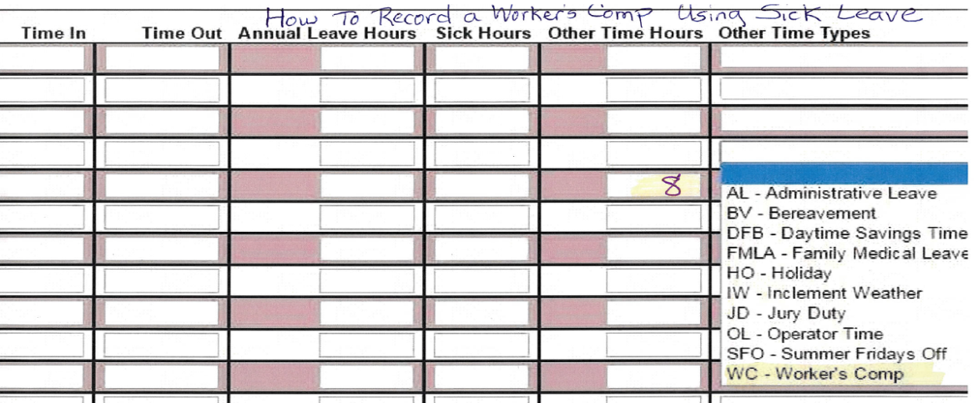

Payroll will use the sick-time accrual first and vacation accrual second unless directed otherwise by the employee.

VII. What if an injured worker files a claim for an injury that did not occur at work?

Filing a worker' compensation claim for an injury that did not occur while performing work on behalf of your employer is a serious offense. It is a violation to knowingly or intentionally do one of the following in an attempt to obtain workers' compensation benefits for yourself or another person:

make a false or misleading statement
misrepresent or conceal a material fact
fabricate, alter, conceal, or destroy a document
conspire to commit one of the above acts

In addition to being an administrative violation, intentional commission of any of the above acts in an attempt to obtain benefits may also result in criminal charges.

How can I obtain more information about Workers' Compensation Insurance?

For more information, contact Human Resources by calling (512) 863-1807, the Local DWC Field Office (800) 252-7031 - option one, or Travelers, your workers' compensation carrier at (800) 235-3610 or refer to http://www.tdi.texas.gov/wc/.

