MODEL RUBRIC – ARGUMENT PAPER for DR. BURKS’S BIODIVERSITY CLASS
(Developed with Dr. Bourque – prompt is available on following page)

 | Unsatisfactory | Satisfactory | Good Quality | Excellent
Clear statement of support for teaching the text | Statement absent or unclear. Argument muddled by tangential information. | Statement present but it lacks justification or reference to TEKS standards. | Clear statement present with some justification but does not draw on more than one TEKS standards. | Clear statement present that integrates text with multiple TEKS standards.
Critical review of biological principles | Either one or two biological principles not pointed out clearly or explained. | Both principles mentioned but not critically evaluated. | Only one element critically evaluated. | Both principles clearly identified and evaluated for validity.
Connection to course content, resources and primary literature | Minimal effort. Only points out obvious connections to course content. No supportive sources. | Touches on basic principles of course on a broad level without providing any explanation. | A few connections to course content apparent and supported by citations and specifics. | Essay shines with connections to course content, resources and uses proper citations of primary literature.
Engaging style and grammatically sound | Generic, not engaging, Lacks flow and continuity.  Multiple grammatical errors that make essay difficult to read. | Attempt in engagement apparent but not as successful as possible. Several grammatical errors distract from content. Passive voice prevalent. | Engaging but minor grammatical errors present.  Generally good flow although some lack of transitions. Integrates active voice well. | An engaging, creative, well put together and supported argument that flows from one point to the next without interruption. Grammatically perfect.

Customized Feedback:

Final Grade: ___________out of 50

Assignment Prompt -- A critical examination: There's a Hair in My Dirt by Gary Larson

Imagine that you have been hired as a curriculum consultant for the Texas State Board of Education. Starting at the age of kindergarten and continuing through elementary school, the Texas educational standards suggest that young children students should be able to:
1. Demonstrate how to use, conserve, and dispose of natural resources and materials such as conserving water and reusing or recycling paper, plastic, and metal.
2. Ask questions about organisms, objects, and events observed in the natural world;
3. Differentiate between living and nonliving things based upon whether they have basic needs and produce offspring;
4. Examine evidence that living organisms have basic needs such as food, water, and shelter for animals and air, water, nutrients, sunlight, and space for plants; and
5. Gather evidence of interdependence among living organisms such as energy transfer through food chains and animals using plants for shelter.

Assignment:
Drawing on the resources and discussions of our Biodiversity course, write a formal, cohesive 750-800 word essay that either recommends or discourages the adoption of There's a Hair in My Dirt as a means to teach biodiversity and conservation principles to elementary school students (consider age in your essay).

Writing Expectations:
- Essay includes a clear statement of support or disapproval for using the cartoon to teach young children (range 5 – 10), one or more of the above principles with justification. Justification includes providing a clear argument supported with a reasoned discussion of logical and compelling evidence.
- Essay contains a critical review of two biological principles from Larson’s text. Support your argument with reference to passages in Larson’s text that get biodiversity right or wrong given your understanding of the subject.
- Essay makes clear connections (3 minimum) to course content, including the support of at least one primary literature paper
- Essay format adopts engaging title, style, formal structure, active voice and close attention to proper grammar.

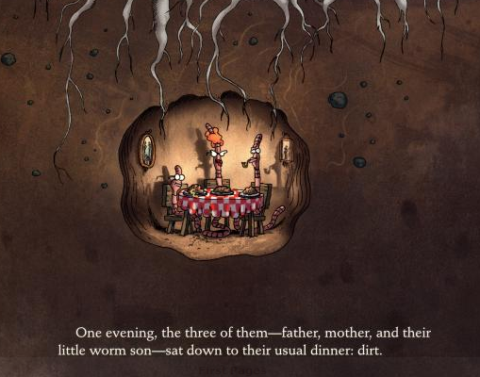
Reference: Chapter 112. Texas Essential Knowledge and Skills for Science Subchapter A. Elementary. Updated 24 August 2010. Accessed from ritter.tea.state.tx.us/rules/tac/chapter112/ch112a.html

