Reviewing Time When You are a Supervisor for Some and an Alternate Supervisor for Others:
By default WebAdvisor always brings up the employees whom you are assigned as their supervisor. If you need to review time entered by employees for whom you are assigned as their alternate supervisor, please follow the steps below.

- Log in to WebAdvisor and select Time Approval (for Supervisors)
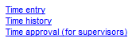

- The students that you are assigned to as their supervisor will appear with the ‘Review Entry’ checked as shown below:
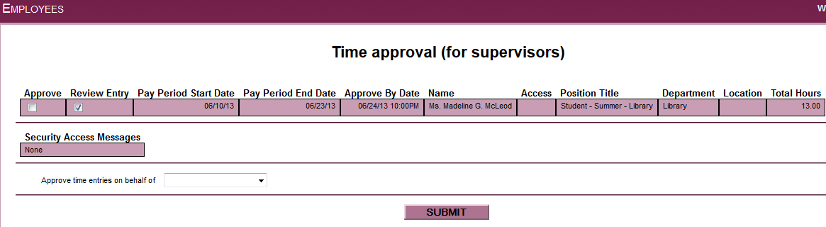

- To review time entered by employees that you are the Alternate Supervisor, you must remove the check mark beside all employees that you see on this page.
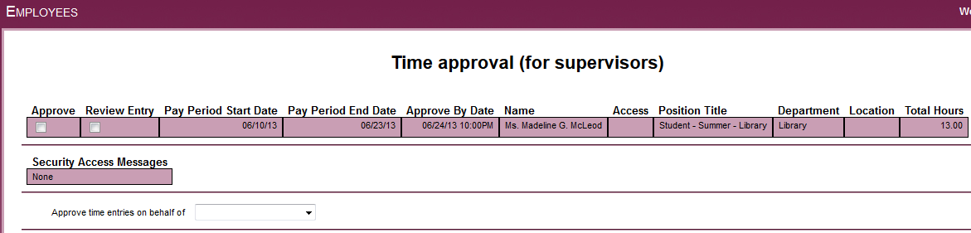
- Then select the name of the supervisor that you will be approving time on behalf of by using the drop down box next to ‘Approve time entries on behalf of’.
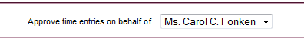

- Hit ‘Submit’

- You will now see the other employees’ time and you may approve or reject it.

