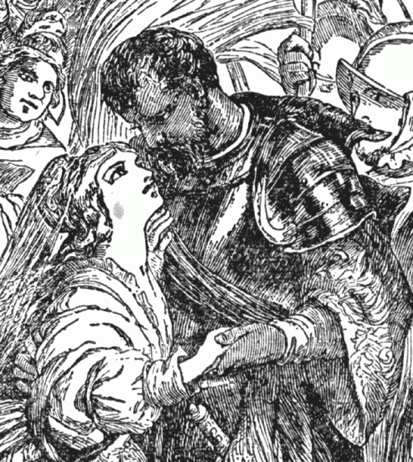

Howard-Crawford Lecture Series
Hosted by the English Department

Screening of Orson Welles' Othello
Followed by a Q&A from Dr. Scott Newstok
Monday, March 17th, at 7:30 p.m.
Olin 110

"Crafting Freedom"
Presented by Scott Newstok
Tuesday, March 18, at 4:00 p.m.
Connie McNab Ballroom

Scott L. Newstok is Associate Professor of English at Rhodes College, where he coordinates the Pearce Shakespeare Endowment, is President of the Phi Beta Kappa chapter, and won the 2012 Campus Life Award for Outstanding Faculty Member. Dr. Newstok joined the Rhodes faculty after teaching at Oberlin College, Amherst College, and Gustavus Adolphus College, as well as holding the Andrew W. Mellon Post-Doctoral Fellowship in the Humanities at the Yale University Library Special Collections. He has published a monograph on the poetics of English Renaissance epitaphs (Quoting Death in Early Modern England [Palgrave, 2009]), produced a scholarly edition (Kenneth Burke on Shakespeare [Parlor Press, 2007], and co-edited (with Ayanna Thompson) a collection of essays on race and performance (Weyward Macbeth [Palgrave, 2010]). His widely-cited "Plea for Close Learning" appeared in Inside Higher Ed and Liberal Education (2013).

