Overview
This process documentation is to assist employees with time entry.

Time Entry Deadline
Pay period ends on Sunday. Please see published schedule on the Business Office web page.
Time must be entered online by the next day (Monday) at 10 am.

Step 1
1a. In a web browser go to WebAdvisor and log in.
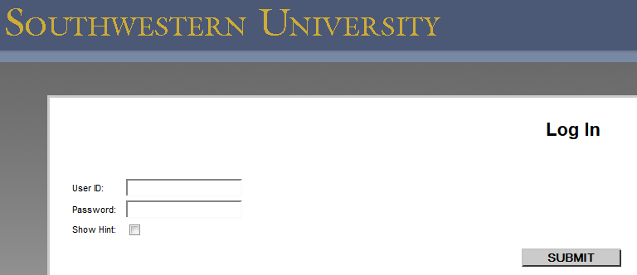

1b. Click on Employees.
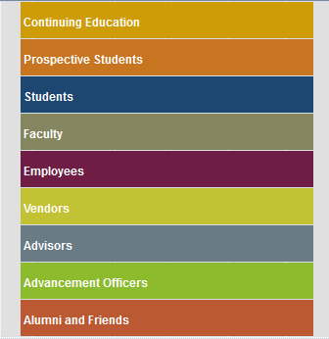

1c. Click on the Time Entry link.
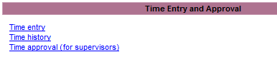

Step 2
2a. You will see the following screen:
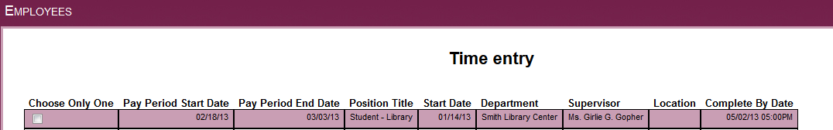
Step 2b

2b. Click the box under “Choose Only One” for the position for which you are entering time.
- (If you have more than one job, there will be multiple listings on the screen shown in Step 2a above.)
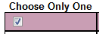

2c. Click on SUBMIT to access time card.

Step 3
3a. The following will be displayed.
- Note: The Annual Leave, Sick, Other Time Hours and Other Time Types columns do not apply to student employees.
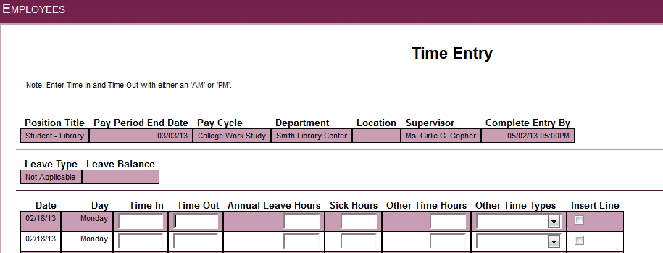
Step 3c
Step 3b

3b. Enter Time In and Time Out for the appropriate dates.
- Enter time with ‘a’ or ‘am’, or ‘p’ or ‘pm’.
  - Example 1: 9:00 in the morning is entered as 9:00am or 9a
  - Example 2: 4:00 in the afternoon is entered as 4pm or 4p
  - Example 3: 1:30 in the afternoon can be entered as 0130pm or 1:30p

3c. (OPTIONAL) Insert line if needed.
- Two lines for each day appear automatically. You can insert a line if needed by clicking on Insert Line.
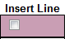

Step 4
4a. Submit the time entered. [ENTER] or click on SUBMIT.
- Note: Time should be entered during each shift, as you work.

4b. You will then see the following:
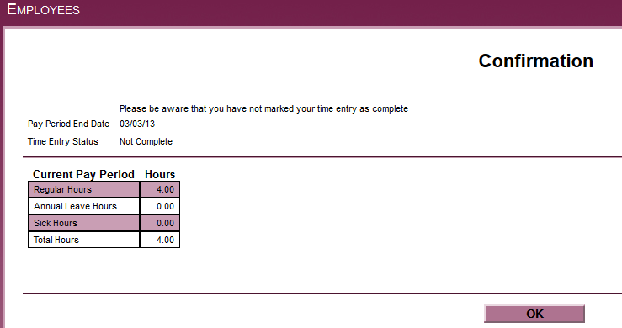

4c. Click OK to close.

Step 5
5a. Once all time is entered for the pay period you will “sign” the time card by clicking on the signature box.

5b. Confirmation screen appears
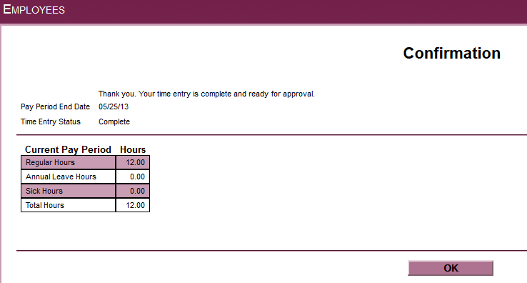

5c. Click OK TO CLOSE.

5d. Log out.

Step 6
Watch email for approval or rejection of time card. You will not have access to this time card again unless your supervisor rejects your time card. If your time card is rejected you will log in and fix any errors and re-submit.

Note – If your time is not submitted by the deadline (Monday at 10am), you will no longer be able to enter it online for that payroll period. Instead, a paper timesheet must be completed, approved by your supervisor, and submitted to the Business Office. Payment will be processed during the next scheduled student payroll.
Please contact Diana Taylor at 863-1931 or taylord@southwestern.edu with questions.

